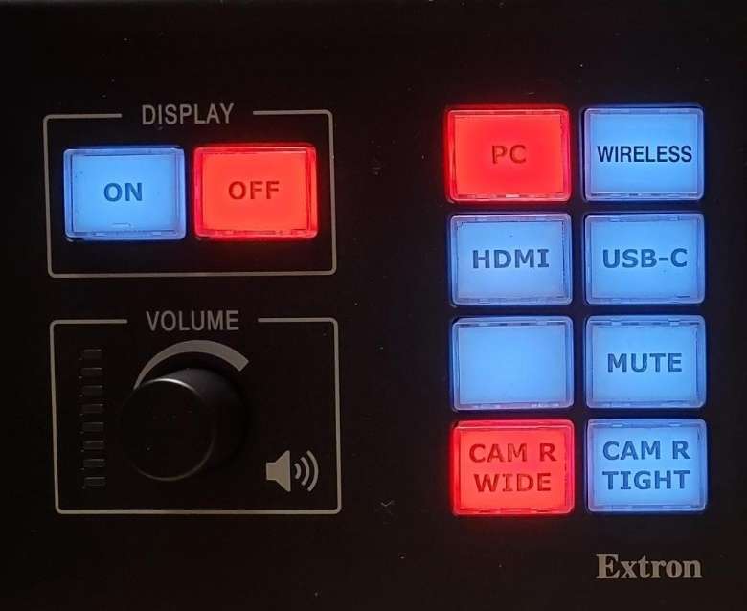
CSL 141

Turning the System On
- Press the display [On] button to turn on the system.
  - The system and projector will turn on.
  - The [MUTE] button is projector mute.

Using the Resident PC
- If PC is not already selected, press the [PC] button on the button panel. (Move mouse)

Using a Laptop
- Connect your laptop to the free end of the [HDMI] or [USB-C] cable on the podium.
- Select the corresponding input that you connected to your laptop on the button panel.
Note: Depending on your laptop model, you may need an adapter. Adapters can be borrowed on short term loan (4hrs.) from an Engineering IT Help Desk.

Using the wireless presenting
- Select [WIRELESS] on the button panel.
- Follow the instructions on the screen.

Adjusting Volume
- Turn the volume knob on the button panel:
  - To the right for louder volume,
  - To the left for quieter volume.

Camera Control
- On the button panel:
  - CAM R WIDE
    - Sets the rear camera on the WIDE preset.
  - CAM R TIGHT
    - Sets the rear camera on the TIGHT preset (close up on speaker at AV podium).

Turning the System Off
- Press the display [OFF] button on the top left of the button panel.

Using the CSL 141 Conferencing System
The CSL 141 conferencing system is built into the room to operate on the Resident PC and Laptops. If using the conferencing system with your laptop, please ensure that the labeled USB cord (labeled MIC CAM) on the podium is plugged into your device and the correct device is selected on the touch screen.

Using the conference system with Microsoft Teams

- Open a Microsoft Teams invite (if it’s not already running), and sign in (if it’s not automatic).
- Before you click “Join Now”:
  - Click on Custom Setup.
  - Select the appropriate Speakers and Microphone for the room – see the devices table below.
  - Scroll down and select the appropriate primary Video device – see the devices table below.
- Or, if you’ve already joined the meeting:
- Verify the audio and video settings:
  - Click the three dots in the top right (above “More”), then select Settings.
  - In the Settings Window, select Device Settings from the left menu.
  - Select the appropriate Speakers and Microphone for the room – see the devices table below.
  - Scroll down and select the appropriate primary Video device – see the devices table below.

Using the conference system with Zoom

- Open Zoom and sign in using SSO (Illinois.zoom.us)
- Verify the audio and video settings:
  - Click on your user icon in the upper right corner of Zoom, then select Settings.
  - In the Settings window, select Video from the left menu.
  - Select the appropriate primary video device for the room – see the device table below.
  - Ensure that the other video settings match your preferences.
  - In the Settings window, select Audio from the left menu.
  - Select the appropriate Speaker and Microphone for the room – see the device table below.
  - Ensure that the other audio settings match your preferences.
- Place your call or join your meeting.

Camera Device | Speaker Device | Microphone Device
USB Capture SDI 4K + | ExtronScalerD (Extron HDMI (3- HD Audio Driver for Display Audio) | Echo Cancelling Speakerphone (TesiraFORTE)

