Siebel Center 4403
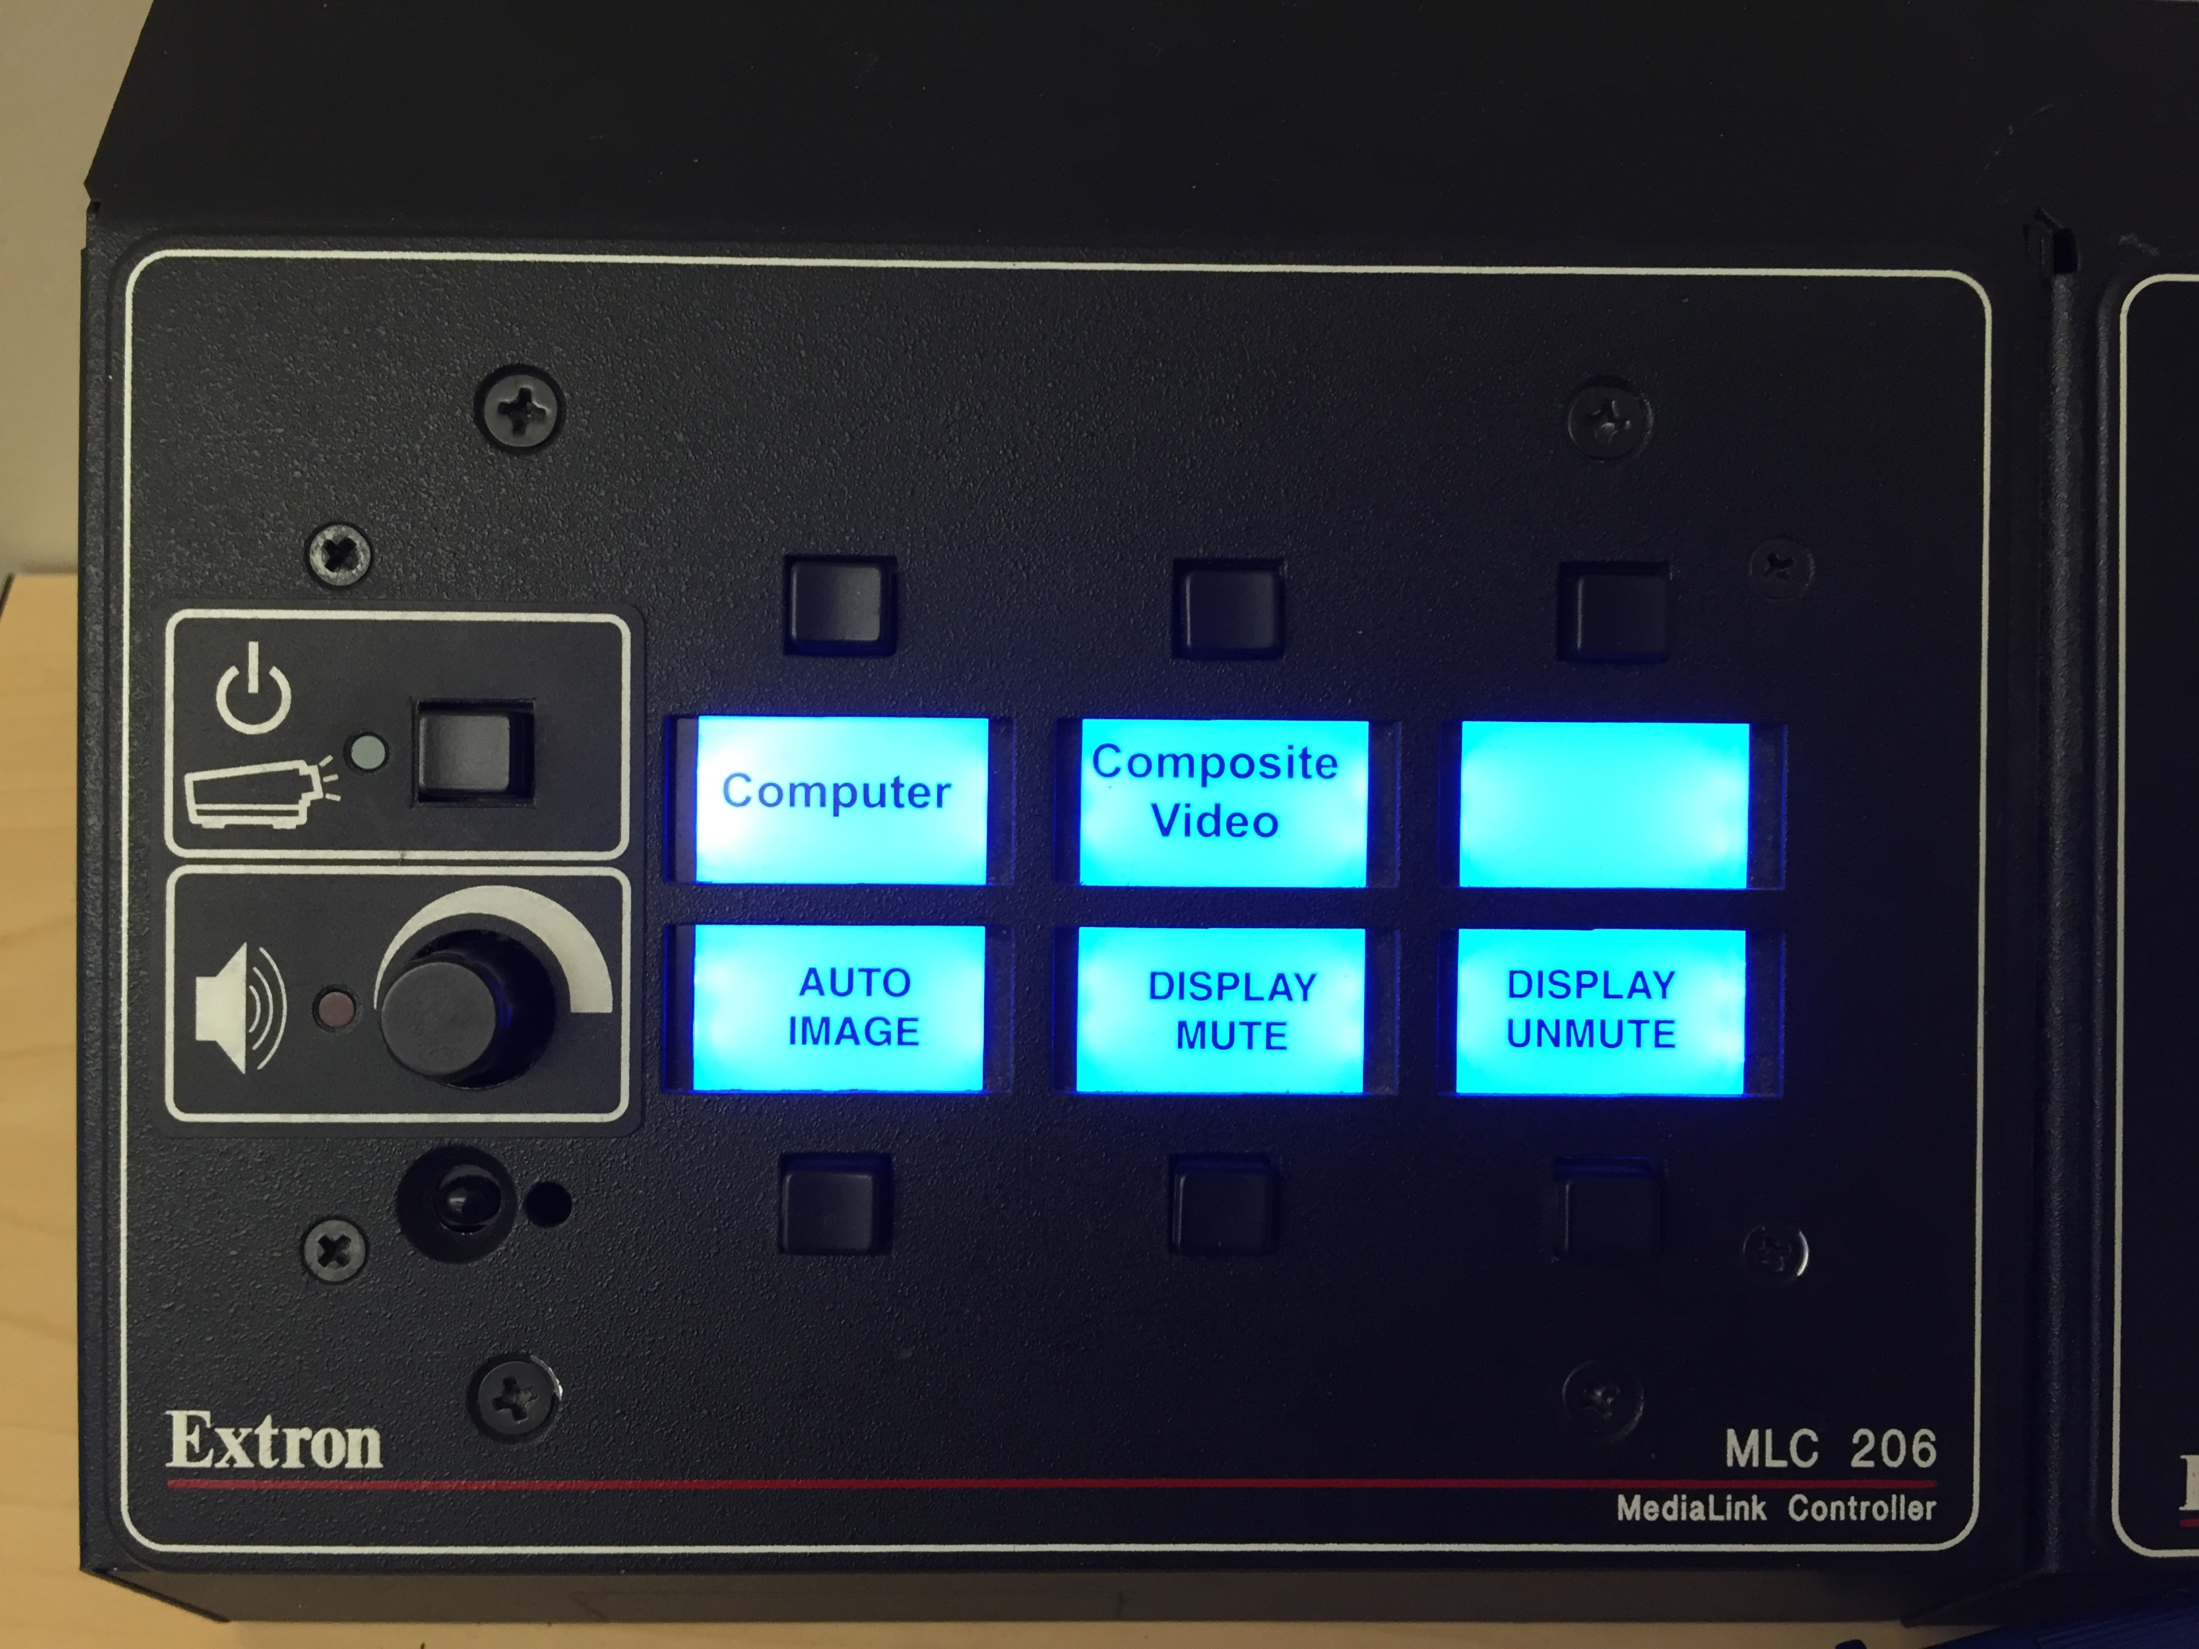

Turning the System On
- Press the power button once.
- The buttons will flash for approximately 30 seconds as the projector starts up. You may now select a source (The Apple TV is the default source).
Note: The system must be turned on before sources can be selected.

Using a Laptop
- Connect your laptop to the end of the VGA cable that is not connect to the input panel.
- Select the [Computer] button on the control panel.
Control Panel
Note: The input panel on this system has two VGA ports. One is labeled [Input] and the other is labeled [Monitor]. Ensure the VGA cable is plugged into the [Input] port.

Using a Composite Video Device
- Connect an RCA cable (user provided) between your device and the composite video ports on the input panel.
- Select the [Composite Video] button on the control panel.

Turning the System Off
- Press and hold the power button for 6 seconds.
- The buttons will flash for 30-90 seconds as the system shuts down.

